**Topic: Multi-user Chat Application using TCP**

**Introduction:**

Multi-user chat applications are a fairly common communication platform used these days in teleconferencing or public chatting to bring people together despite geographical barriers. They are built such that multiple users can act as both clients and servers at the same time to facilitate crowd communication, such as in group chats where message must be broadcasted to all connected users.

**Overview:**

We have designed a multi-user chat application driven by a chat server which delivers incoming messages to clients in the chat.

The server gathers all client sockets in dictionary for sending them messages.

Our concepts of Client-Server architecture are being modelled in this project.

There is a multi-threaded chat room server.

It consists of a Client Application that must on user’s PC and a server application which runs on any PC in the network. To start chatting client needs to establish connection with the server.

**Features:**

* Online users visible on the server side
* Unique usernames
* Multi-threaded chat room
* Both server and clients have ability to clear chat
* Textbox clears after message sent
* All clients aware of online users
* Visible connection status at client side.

**Tools:**

* Netbeans 8.0.2
* Java/ JDK 1.8_20
* Windows 10
* Netbeans GUI

**Code snippets:**

**Server side:**

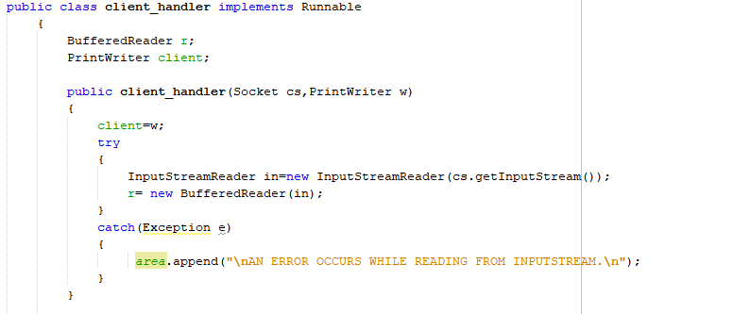

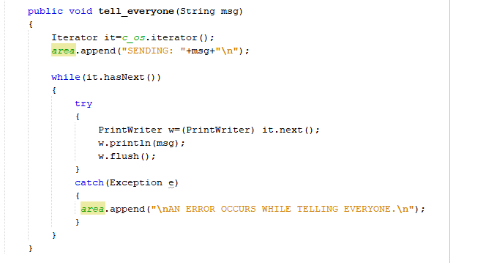

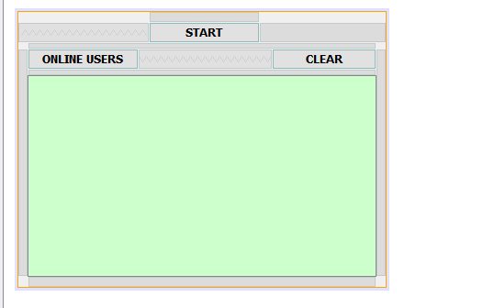

**client side:**

